* Data Structure

MongoDB is a document store.. not confined by schemas. **Can store data in DB almost exactly as represented**..

* Performance

MongoDB inserts/reads can on some areas perform substantially faster than relational databases.

* Scalability

Linear scalability it‘s easy to add more servers to your server farm just by adding a new shard to your DB and MongoDB takes care of setting up and integrating the shard to the farm.

**Cons:**

* Data integrity

With the schema freedom it is more in the hand of the programmer to ensure data integrity.

* Bloated database

You could have a lot of recurring data, i.e. when you don‘t have relationships you tend to just store the same data over and over again.

**Data Models**

Models in MongoDB have flexible schemas called **Collections** which are similar to SQL... stored in a **BINARY JSON** string called **BISON**.

Can have different properties in objects in a collection.. **not good for data integrity..**

**Indexes**

Indexes are special data structures that store a small portion of the collection‘s data set in an easy to traverse form.

All have indexes on the _id field.

**Replication**

A way to increase data availability and provides a redundancy plan for server failure. A replica set the primary node accepts all write opreations from clients and replicates it to secondary node.

**Sharding**

Sharding is a method for storing data across multiple machines. MongoDB uses sharding to support deployments with very large data sets an dhigh throughput operations.

Skip detials..

Mongo:

Show collections..

Db.grades.insert({ ‚user‘ : ‚hlysig‘, ‚course‘ : ‚Forritun 1‘, ‚grade‘ : 4}

**Mongoose** can be used to connect to MongoDB.

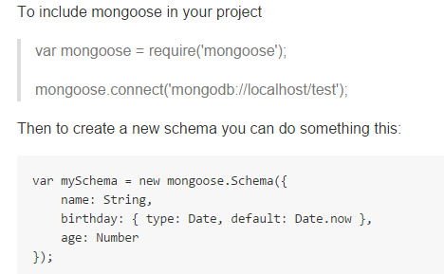

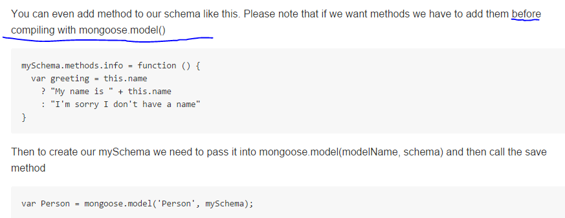

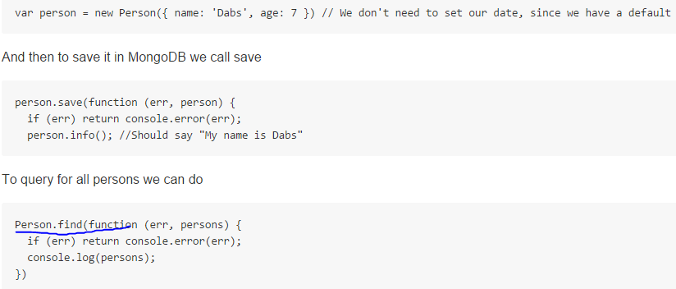

**VALIDATING IN MONGOOSE**

* Validation is defined **in the schema**
* **OCCURS WHEN DOCUMENT ATTEMPTS TO BE SAVED**
* Validation is asynchronously recursive, when you call the save function, validaiton is executed.. if an error occurs.. **YOUR SAVE FUNCTION CALLBACK RECEIVES IT..**

